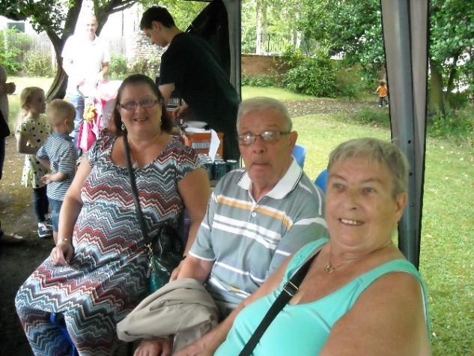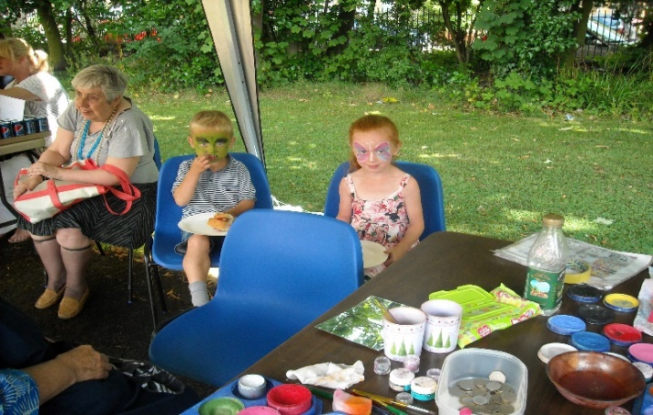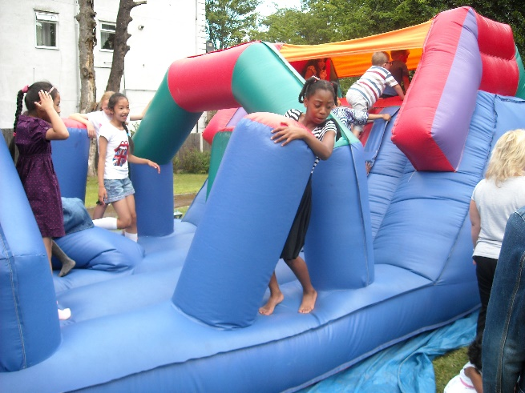

**Parish BBQ Sunday 24th July**

**12noon – 3pm**

**St Sebastian’s Presbytery**

**18 Lilley Road**

**Tickets Adults £2 Children £1**

(Includes Burger and a drink)

Bouncy Castle, Face Painting,

Tombola’s, Bric-a-Brac,­­­

Home-made cakes,

Afternoon tea and strawberries

**All Welcome**