INCLUSION
CHARTER MARK

ST. OSWALD’S CATHOLIC PRIMARY SCHOOL
Email: office@st-oswalds.liverpool.sch.uk www.stoswaldsschool.com
Montague Road
Liverpool L13 5TE
Headteacher: Mrs. M. Walsh
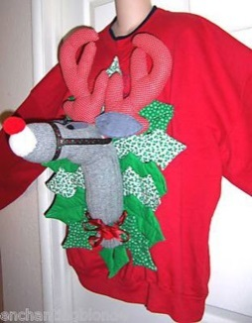
Telephone:
0151 228 8436

Make the World Better with a Sweater

Dear Parents/Carers,
As we enter the season of Advent in preparation for the Christmas celebrations, on our website is the lists of events and relevant dates. www.stoswaldsschool.com, I hope that as many of you as possible will join us for some of them but especially any of the school Collective Worships of the Nativity.
As is normal practice for all Catholic schools, December sees the start of our collection on behalf of Cafod, the Catholic association for overseas development. Each class will be choosing a gift from the Cafod brochure that they would like to send to someone on behalf of their classes; the gifts range from chirpy chicken to helping to fund a community toilet! The children do something positive to rediscover the real meaning of Christmas, sharing the love, peace and joy at this special time of year. If you could encourage your child to donate some of their pocket money, then they will be fully embracing the Christ in Christmas.
To help towards this cause on Tuesday 13th December the children are invited to attend school in either Christmas jumpers or in jumpers decorated with Christmas baubles, tinsel etc., nobody should go to any additional expense; the home decorated jumpers are always the best!
The children should pay £1.00 towards the fundraising day and half monies will be spent by the classes choosing their special gift and half to Save the Children.
This day is also Christmas dinner day so will be a lovely celebration in school.
Yours sincerely
Mrs M Walsh
Head Teacher

Yours Sincerely,

Head Teacher

Together with Jesus, we will Learn and Grow in Faith

