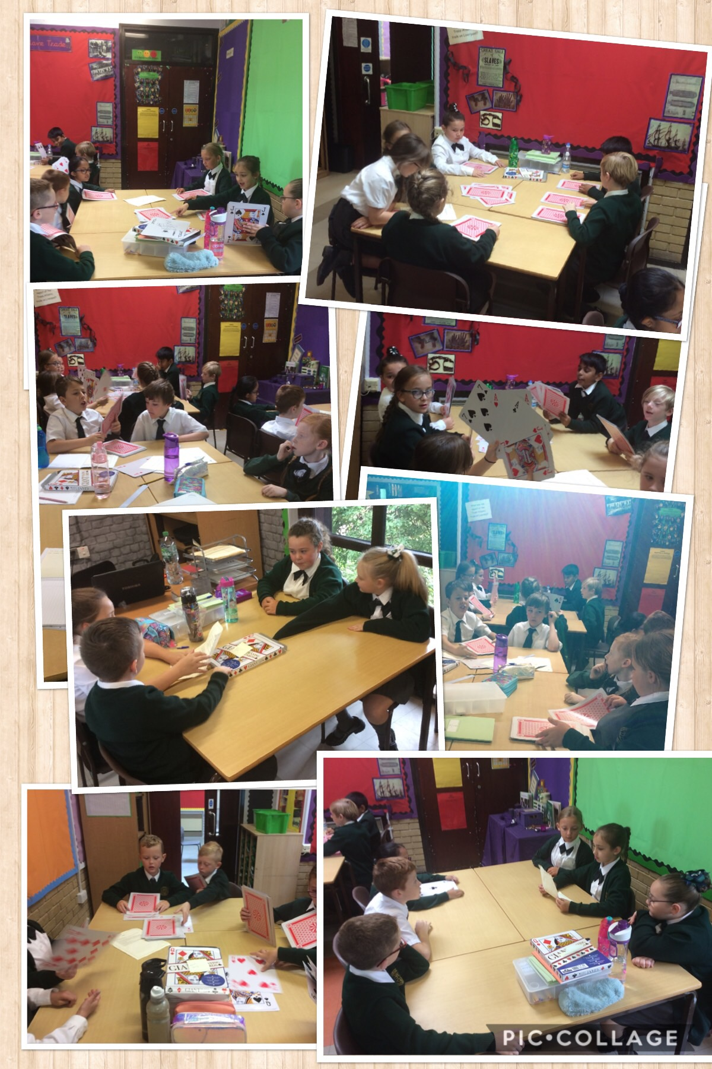
In Year 5 we have been looking at a range of different instruction texts and learning how to write our own set of instructions. We have looked at texts including recipes, how to play games and have been writing our own instructions on how to kill a vampire!

