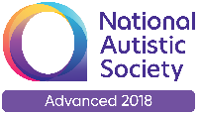
The ASD Training Team

The Liverpool ASD Training Team are providing a series of virtual drop in advisory sessions via zoom. They are for parent/carers wishing to talk in a private one to one setting about any questions or concerns they may have about their child. You do not require a diagnosis of ASD to book your place.

Tuesday 21st July 2020 Wednesday 22nd July 2020
9.30 – 10.15

10.30 – 11.15

11.30 – 12.15

1.30 – 2.15

2.30 – 3.15

9.30– 10.15

10.30 – 11.15

11.30 – 12.15

1.30 – 2.15

2.30 – 3.15

Thursday 23rd July 2020
9.30 – 10.15

10.30 – 11.15

11.30 – 12.15

1.30 - 2.15

2.30 – 3.15

To book your place please email your choice of date and time and you will be emailed a zoom link. There are two places available for each time slot.
asdtrainingteam@liverpool.gov.uk

