INCLUSION
CHARTER MARK

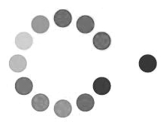
ST. OSWALD’S CATHOLIC PRIMARY SCHOOL
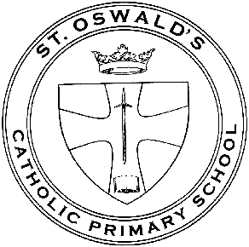Email: office@st-oswalds.liverpool.sch.uk www.stoswaldsschool.com
Montague Road
Liverpool L13 5TE
Headteacher: Mrs. M. Walsh
Telephone:
0151 228 8436

Advice to All Parents - Single Case Nursery

Dear Parents,

We have been advised by Public Health England that there has been a confirmed case of COVID-19 within the school.

We know that you may find this concerning but we are continuing to monitor the situation and are working closely with Public Health England. This letter is to inform you of the current situation and provide advice on how to support your child. Please be reassured that for most people, coronavirus (COVID-19) will be a mild illness.

The small number of children who have been in close contact with the individual who has tested positive for coronavirus (COVID-19) have received a letter asking them to stay at home for 10 days.

The school remains open and your child should continue to attend as normal if they remain well.

What to do if your child develops symptoms of COVID 19

If your child develops symptoms of COVID-19, they must not come to school and should remain at home for at least 10 days from the date when their symptoms appeared. Anyone with symptoms will be eligible for testing and this can be arranged via https://www.nhs.uk/ask-for-a-coronavirus-test or by calling 119.

All other household members who remain well, must stay at home and not leave the house for 10 days. This includes anyone in your ‘Support Bubble’.

Further information is available at: https://www.gov.uk/government/publications/covid-19-stay-at-home-guidance/stay-at-home-guidance-for-households-with-possible-coronavirus-covid-19-infection

The 10-day period starts from the day when the first person in the house became ill.

Household members should not go to work, school or public areas and exercise should be taken within the home.

If you require help with buying groceries, other shopping or picking up medication, or walking a dog, you should ask friends or family. Alternatively, you can order your shopping online and medication by phone or online.

Household members staying at home for 10 days will greatly reduce the overall amount of infection the household could pass on to others in the community

If you are able, move any vulnerable individuals (such as the elderly and those with underlying health conditions) out of your home, to stay with friends or family for the duration of the home isolation period.

Symptoms

The most common symptoms of coronavirus (COVID-19) are recent onset of:

- a new continuous cough
- a high temperature
- a loss of, or change in, your normal sense of taste or smell (anosmia)

For most people, coronavirus (COVID-19) will be a mild illness.

If your child does develop symptoms, you can seek advice from the nhs.uk website at https://www.nhs.uk/conditions/coronavirus-covid-19/check-if-you-have-coronavirus-symptoms/. If you are concerned about your child’s symptoms, or they are worsening you can seek advice from NHS 111 at https://111.nhs.uk/ or by phoning 111.

How to stop COVID-19 spreading

There are things you can do to help reduce the risk of you and anyone you live with getting ill with COVID-19

Do
- wash your hands with soap and water often – do this for at least 20 seconds
- use hand sanitiser gel if soap and water are not available
- wash your hands as soon as you get home
- cover your mouth and nose with a tissue or your sleeve (not your hands) when you cough or sneeze
- put used tissues in the bin immediately and wash your hands afterwards

Further Information
Further information is available at https://www.nhs.uk/conditions/coronavirus-covid-19/

Yours sincerely
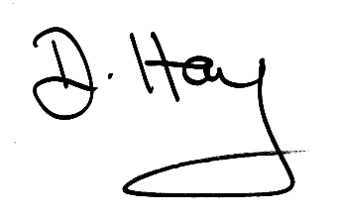
Miss D Hay
Deputy Head

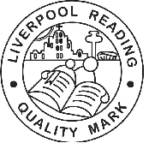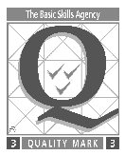 Together with Jesus, we will Learn and Grow in Faith

