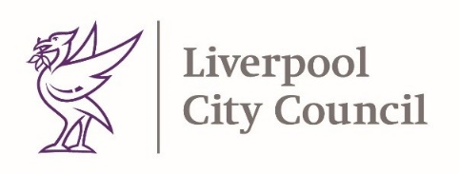

22nd October 2021
Dear Parent / Carer,
We are once again seeing worryingly high levels of COVID infections in Liverpool, with highest numbers in school children. The impact of COVID is a risk to everyone. Rising infections will mean more children becoming ill, needing to isolate from their friends, disruption to learning and more strict measures being re-introduced next term in schools.
We wanted to thank you for your support but also urge you to act now. Help us keep your child safe, in school with their friends next term and reduce the future impact of COVID on their lives by taking a few simple steps now.
No measure is perfect and we are recommending a few carefully selected measures, which we feel will have minimal impact on education and are effective at reducing risk of transmission – but for these to work everyone has to play their part now.
Parent, carers and guests should wear face coverings when in and around the school, unless medically exempt. This includes when collecting and dropping off your child(ren). Wearing a face covering is the most effective way to reduce your risk of infection or spreading the virus.
Vaccination is our first line of defence against COVID. If you have been called for the vaccine, please take up the offer. You can book your vaccine on the following here (https://www.nhs.uk/conditions/coronavirus-covid-19/coronavirus-vaccination/book-coronavirus-vaccination/)
Even if you haven’t been testing before, now is the time to start. It is essential that you and any eligible household members still use twice-weekly lateral flow tests and report the results (https://www.gov.uk/report-covid19-result). Continued regular testing over half term will help reduce the risk of household infections when returning to school.
Stay COVID safe. A few additional steps will help reduce your risk of infection, keep washing your hands or using alcohol gel, socialise outdoors and when inside ventilate the room. If you develop COVID symptoms, it is essential to isolate immediately, get a PCR test as soon as possible and let the school know. The main symptoms are still a high temperature, a new, continuous cough and a loss or change to your sense of smell or taste.
We wish you all a COVID safe and enjoyable half term.

Yours Sincerely
Matt Ashton
Director of Public Health
Steve Reddy
Director of Children’s Services

